## Intro

When I was first given the assignment to come up with a problem and to design a website or an app to solve the problem I had no idea what to do. Then I was getting a bus to work, a generally bad bus and it was late as usual and I was just wishing I could see where it was because I know the route it takes and if I saw it, I could time it for myself. I then thought that’s what I should do. I began my research with my interviews to see who my idea would be useful to.

**Interview Pilot**

Your interview should last approximately 15 minutes, during which you want to explore your interviewee’s *attitudes*, *aptitudes*, *activities*, *motivations* and *skills* which are relevant to the problem you’re trying to solve with your design. You should complete the following form and bring it to class next week.

|  |
| --- |
| **Problem**:  To make timing the bus much easier, by tracking it on a map and letting the user calculate when it will arrive. |
| **Interview guide**:  Do you normally use the bus on a day to day basis?  How often would you use the bus?  Do you time the bus if you do use it?  Is the bus timer you use always accurate?  If you could see the bus on a map do you think it would be easier to time? |
| **Behavioural variables**:  *Likes to travel alone Likes to travel in groups*  *Middle doesn’t mind either way.* |
| **Characteristics**:  *Irish*  *Non-bus user\**  *49*  *Has children that use the bus* |
| **Next interview**:  *Interview a bus user next*  *Younger age*  *Student* |
| **Identifier**:  *#1* |
| **What worked well**:  *Even though interviewee was not a bus user was still very interested in the idea I have come up with* |
| **What did not work well**:  *The questions I had prepared were answered mostly no* |
| **What you would do differently next time**:  *If I was interviewing a non-bus user again I would ask questions in relation to other people e.g their children or people they know who use the bus* |

I first chose a non-bus user and she was a mother, even though she did not need to use it for herself she said it would be nice if she could see exactly where the bus was that her child was on so that she could start the diner or just so she knows where her child is. Unfortunately the questions I had prepared were answered very quickly and shortly as she was not a bus user.

|  |
| --- |
| **Problem**:  *To make timing the bus much easier, by tracking it on a map and letting the user calculate when it will arrive.* |
| **Interview guide**:  *Do you normally use the bus on a day to day basis?*  *How often would you use the bus?*  *Do you time the bus if you do use it?*  *Is the bus timer you use always accurate?*  *If you could see the bus on a map do you think it would be easier to time?* |
| **Behavioural variables**:  *Likes to travel alone Likes to travel in groups* |
| **Characteristics**:  *Irish*  *Bus user*  *19* |
| **Next interview**:  *Different age group but still a bus user* |
| **Identifier**:  *#2* |
| **What worked well**:  *The questions I asked were relevant and had an extended answer because of this* |
| **What did not work well**:  The fact that my idea was a website and not an app |
| **What you would do differently next time**:  *Show the interviewee my ideas for the website* |

The second person I interviewed was a bus user and the questions I asked were relevant and the interview went well, The only problem was that she said that she would use her phone app to time the bus, rather than a website.

|  |
| --- |
| **Problem**:  *To make timing the bus much easier, by tracking it on a map and letting the user calculate when it will arrive.* |
| **Interview guide**:  *Do you normally use the bus on a day to day basis?*  *How often would you use the bus?*  *Do you time the bus if you do use it?*  *Is the bus timer you use always accurate?*  *If you could see the bus on a map do you think it would be easier to time?* |
| **Behavioural variables**:  *Likes to travel alone Likes to travel in groups* |
| **Characteristics**:  *Irish*  *Non-Bus user*  *19* |
| **Next interview**:  *Different age group but still a bus user* |
| **Identifier**:  *#3* |
| **What worked well**:  *That even though he was not a bus user still interested in my idea to see where his friends were and how long they would be* |
| **What did not work well**:  The fact that my idea was a website and not an app and he did not use the bus |
| **What you would do differently next time**:  *Show the interviewee my ideas for the website* |

For my third user I interviewed another age group a non-bus user and again he found my idea smart and interesting

|  |
| --- |
| **Problem**:  *To make timing the bus much easier, by tracking it on a map and letting the user calculate when it will arrive.* |
| **Interview guide**:  *Do you normally use the bus on a day to day basis?*  *How often would you use the bus?*  *Do you time the bus if you do use it?*  *Is the bus timer you use always accurate?*  *If you could see the bus on a map do you think it would be easier to time?*  *Do you think that my website would be useful?*    *What would you change?* |
| **Behavioural variables**:  *Likes to travel alone Likes to travel in groups* |
| **Characteristics**:  *Irish*  *Bus user*  *79* |
| **Next interview**:  *Different age group but a non-bus user* |
| **Identifier**:  *#4* |
| **What worked well**:  *The questions I asked were relevant and had an extended answer because of this* |
| **What did not work well**:  Trying to explain the website without a laptop |
| **What you would do differently next time**:  *Have an interview with someone that is used to modern technology.* |

For my fourth interview I chose someone of an older age group to get more of an idea of making the website easy for everyone to use. The lady I interviewed did not own a smartphone but did own a laptop so I gave her a look at my idea for my website and explained for a while, she said she thinks that it is good because it is easy to use.

|  |
| --- |
| **Problem**:  *To make timing the bus much easier, by tracking it on a map and letting the user calculate when it will arrive.* |
| **Interview guide**:  *Do you normally use the bus on a day to day basis?*  *How often would you use the bus?*  *Do you time the bus if you do use it?*  *Is the bus timer you use always accurate?*  *If you could see the bus on a map do you think it would be easier to time?*  *Do you think that my website would be useful?*    *What would you change?* |
| **Behavioural variables**:  *Likes to travel alone Likes to travel in groups* |
| **Characteristics**:  *Irish*  *Bus user*  *24* |
| **Next interview**:  *Last interview* |
| **Identifier**:  *#5* |
| **What worked well**:  *The questions I asked were relevant and had an extended answer because of this* |
| **What did not work well**:  Interviewee has no phone, so no internet outside his house |
| **What you would do differently next time**:  *Have an interview with someone that has a phone and mobile internet* |

For my final interview I interviewed someone a little older but still used the bus and he did not have a phone so he just checked the bus when he had Wi-Fi on his ipod. He said that my idea would work better for him because he would be more inclined to look at the bus and time it before he went out to the stop.

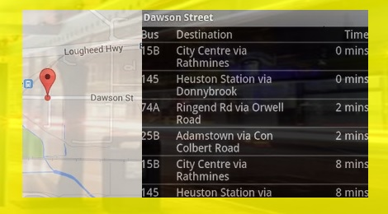

After I had shown him my template idea he was very impressed and was very sure that he would use it himself if it one day became fully functional and he would use it above the real time bus app.

Overall it seemed like my idea was a good one and that it was relevant to all the people I interviewed. I then began to wonder if there was anyone that I had left out and I began my research on that. I was worrying that some people might not be able to use my website but then I realised that the internet is universally usable by all people disabled and not. I then started to think about the buses themselves and was wondering if they can accept all types of people onto them and I found out yes they can I stumbled across this when doing my blog

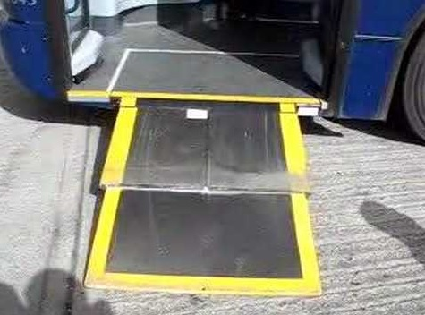

I was not sure if all buses could accept wheelchairs on and then I came across this and was relieved to see that they can.

**The Viper**

**Gender:** Male

**Age:** 20

**Location:** Dublin, Ireland

**Occupation:** Full-time Student



**Motivations:**

The Viper is very motivated about going to college to get an education and getting qualified. He is motivated to attend all his classes and be on time for lectures. He loves being on time. The Viper is a family man and likes to know where his family is e.g his grandmother and younger brothers. If he could see what bus they were taking on a map and knew where they were it would calm his nerves. He would also like for them to be able to time the bus so that they are home in time etc. His grandmother does not know how to use iphones etc. so he would like to have a website that is easy to navigate and that she can use without trouble.

**Goals**

* To graduate with a masters
* Make the most of his time in college
* Be punctual
* Make his family proud

**Frustrations:**

The Viper hates having to wait for the bus in the cold and not knowing if the bus is late or not. He hates being late to college and for lectures. He can’t afford a car because he is a student without a job. Does not have time to be waiting around for buses would like to use a quick and simple system to check where the bus is and an accurate time of arrival.

When creating my persona I tried to make it relevant to everyone I interviewed and since the majority were bus users I went with that. I made clusters of information that overlapped in my interviews and added it all into my persona so as I could portray that all people can use my website no matter what age or problem. My persona shows that it is useful to the student himself and also to his elderly grandmother and younger siblings. It shows that it is universally usable and simple to navigate.

## Scenario 1

It is an early morning and Derek has to take the bus to work, unfortunately none of the bus stops around his area have shelter and it is a horrible morning pouring rain and he doesn’t have an umbrella his mother took it for herself. He does not really want to be waiting at the bus stop in the rain so he wants to time it so when he gets to the stop the bus will be there, the real time bus app is usually wrong so he wants another way to track his bus.

## Scenario 2

It is a cold winters day and it is snowing outside Ruth has to go to the doctor for her prescription to get her pills and does not really want to be standing around in the cold waiting on a bus, she does not have an iphone because she does not really know how to do one but she would like to know when exactly the bus arrives so she can spend as little time in the cold as possible so she would like a way to see her bus and time it herself.

## Scenario 3

Bosco thought he’d be brave and go on a session on a Saturday and have woken not in the best of shape and if he is late to work he is definitely getting the sack. He needs to go through the morning routine to look half decent, there is no chance of getting behind the wheel because he is definitely over the limit. He wants to check the buses near him and time them accurately but misplaced his phone on his escapade. He wants another way to check the bus.

I then went on to try and push my website a bit to see if it will really work and I did so with three quite bad situations to see if my website would come in handy when it was really needed. I think it passed as it would be useful in all three scenarios to actually see where your bus is to get an idea of how long it will actually be. Even in the worst case scenario it seemed to still be of use so it definitely passed that test from my point of view.

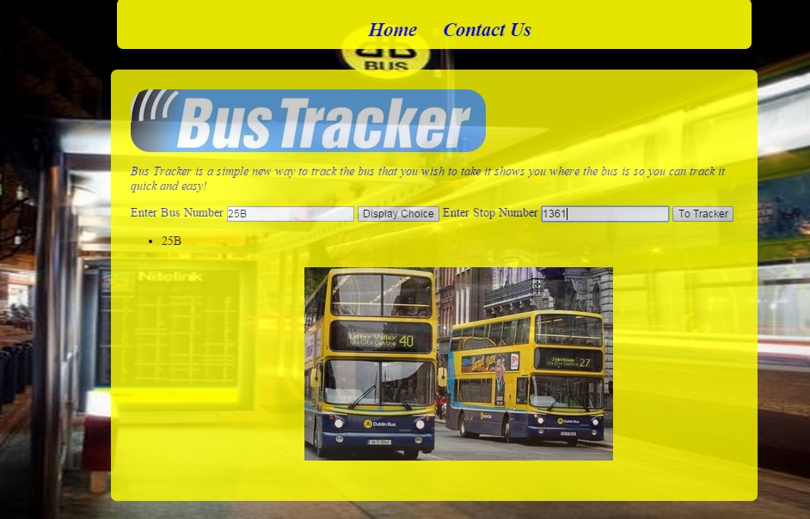

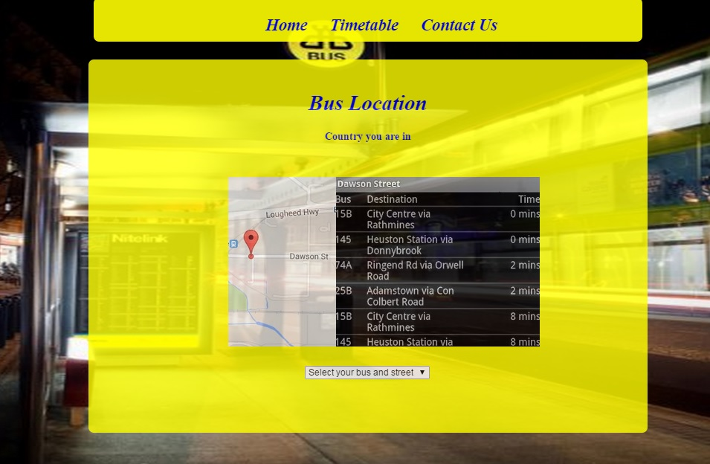

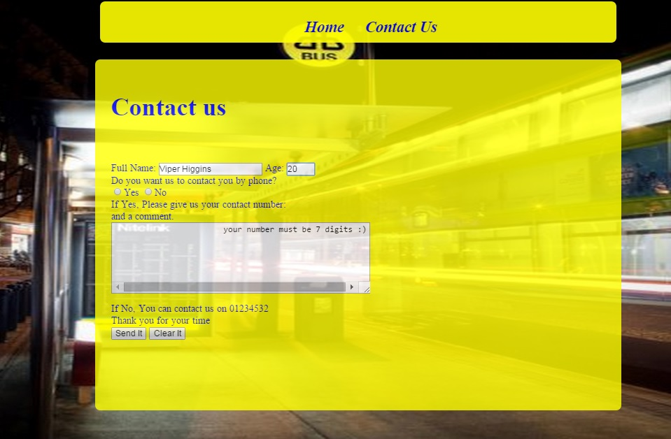

The whole layout and design was to keep it simple stick with the Dublin bus theme and make it easy to use for everyone and I think I accomplished that. As you can see the user just simply enters in the bus number and stop number and you can choose to save the option that’s the idea. It then takes you to the timetable and tracker of the next number bus on the way to the stop. You can choose stops and it will tell you what country you are in to show that it can be adapted with xml files. Finally there is a contact page where you could contact if this was an official site and it stores your name and age when it is entered so you can pick up where you left off. The site is simple and easy to use and it is fast for when you are in a hurry so it meets all the criteria I wanted to meet from my interview and the idea is also expandable. There is javascript on every page one just for the slideshow so it’s fun, the second page for xml to show files can be pulled in and finally on the last page for the cookie storage. There is a little css just so the site isn’t boring but nothing too complicated as I still want to keep it simple.

So to conclude I think that my idea will be a great success if I could get it fully functional with a few more updates and ideas for it. If I could make it into an app I think it would be or successful but as a website I think it would do well also.